Sunderland Tackles Painkiller Addiction
Press release –October 2019
Excessive use of painkillers is on the rise and the North East is currently the highest prescribing area in the country, with Sunderland in particular dubbed ‘the painkiller capital’. Now, Sunderland CCG is tackling the issue head on, by running a public facing campaign to raise awareness of this potentially deadly dependency.
In July 2019 NHS Sunderland CCG was the second highest prescriber* in England for tramadol and codeine with nearly 145,000 prescriptions¹ given out within the first six months of the year.
The citywide campaign aims to raise awareness of the issues, dangers and effects of high-dose, long-term painkiller use to help patients using painkiller medication to feel empowered to seek support. Online information is available at www.PainkillersDontExist.com.
Simultaneously, every GP practice in the Sunderland area has received a range of materials to support the campaign as well as a commitment to limiting new opiate prescriptions to three months and reviewing existing opioid usage.
GPs and pharmacies will work with patients to identify sustainable, alternative pain management techniques for longer term chronic pain.
Dr Saira Malik, Executive GP and Musculoskeletal (MSK) Clinical Lead at Sunderland CCG, who has been leading on reducing prescribing and looking at measures to support patients and clinicians, said: “We know that Sunderland has a high usage of painkiller medication. There are different levels of addiction, which can range from an unhealthy reliance, to dependency through to addiction. Anyone who feels this is an issue affecting them or a loved one should raise it with their GP.
“If a patient feels they are hiding how many painkillers they are taking for example, they’ll know themselves they need help to come off these drugs and local GPs are ready to support that process.
“If you’re someone who has been taking painkillers for several months, we would encourage you to recognise this may be a red flag and discuss your pain management with your GP to see if there are alternative ways to manage your pain and reduce dependency on these highly addictive drugs.”
Opioid painkiller drugs are designed to mask pain and will not cure the problem. But, many people do not recognise their own reliance on painkillers or realise that overuse can lead to dependence and addiction, and the need to physically withdraw.
Dr Rory Mackinnon, GP Partner at Bridge View Medical Group, Southwick said: “Addiction to painkillers can happen to anyone and there is no specific category of patient who is at risk. It is estimated that 5.6 million adults² in England take prescribed opioids and this is particularly predominant in Sunderland. I would encourage anyone who has been taking painkillers for more than two months to make an appointment with their GP to discuss realistic pain management options, in order to prevent unintentional dependency.”
Dr Claire Bradford, medical director of NHS Sunderland, added: “We are aiming for a two-pronged approach to this problem. As well as encouraging opioid users to discuss their painkiller use with their GPs, we are working hard with 220 GPs and their practices across the city to ensure this issue is a priority and offer alternative solutions to pain management for patients.
“It’s important to highlight however, the campaign is not directed at patients with cancer pain, those under palliative care or children.”
The campaign will see a hard-hitting social media campaign along with GP surgery posters and advice cards, roadside billboards, and a new website to provide general and specific local information for people of Sunderland and the North East. It will focus on the theme that painkillers don’t exist as pain can’t be killed, only masked or managed.
Dr Mackinnon continued: “These very strong painkillers should only be used during periods of acute pain, before coming off them altogether or moving to a long-term, managed plan for people who have chronic pain issues.”
Side effects of prolonged prescription pain medication can be truly debilitating and as well as leaving lasting internal damage to organs like your stomach and liver. They can also lead to nausea, stomach pain, vomiting, changes in personality, respiratory issues, confusion, fatigue, anxiety, hallucinations and overdose through accidental poisoning.
The campaign is supported by Jazmine Allen, 23, who has been dependent on opioid painkillers since the age of 12. A university student, she has completed her end-of-year project around the issue of painkiller addiction and has been working with Sunderland CCG.
She said: “As a child I needed pelvic surgery for my hip dysplasia and was prescribed high dose long-term painkillers for chronic pain, which was ongoing through my teenage years. As an adult I recognised this wasn’t helping the pain anymore and decided I wanted to stop taking them.
“I still suffer from chronic pain, but now I am no longer taking opioid medication I can manage my pain better as I don’t suffer the side effects which had taken over my life. I would never have thought I could have become so dependent on my medication, because it was prescribed, but I was. I’ve heard so many similar stories – it’s important to recognise you may have become dependent on your medication and should ask for help to address this.”
The campaign goes live Thursday 10 October.
- Ends –
For more information please email Michelle Horne pr@wearemagpie.com or call 07795 481 671
Statistics:
1 Source: Public Health England
2 Source: Openprescribing.net
About NHS Sunderland CCG
NHS Sunderland Clinical Commissioning Group (CCG) is the statutory health body responsible for the planning and buying of local NHS care and service to meet the needs of the local community.
Working as a clinical commissioning group (CCG) we deliver high quality care, using most appropriate methods and cost-effective resources, to improve healthcare provision for the people of Sunderland and reduce disparities in health and social care. By using effective clinical decision-making we can make a real impact on health, well-being and life expectancy of our patients.
Our vision is to improve the health, wellbeing and life expectancy of the residents of Sunderland, by providing joined up health across the city and achieving “better health for Sunderland”.
Notes to editors
*The data used in this document is from the NHS Business Services Authority who process prescriptions dispensed by community pharmacy in order to process payment claims for items/ drugs dispensed per month. The BSA measures “items” of drugs dispensed which can roughly be translated to amount of prescriptions for particular drugs. Data is accessed directly from the BSA (using a programme called ePACT2) and also from OpenPrescribing.net which sorts the data on a practice level to show prescriptions dispensed per individual GP practices. Generally the data is 2 months behind – the most recent prescribing/ dispensing data available today is from July 2019.
Tramadol – strong opioid used for pain (- would not be used in palliative care or addiction).
Tramadol
In July 2019 (latest data available as of Oct ‘19) Sunderland (highlighted in red) was the second highest prescriber for tramadol.
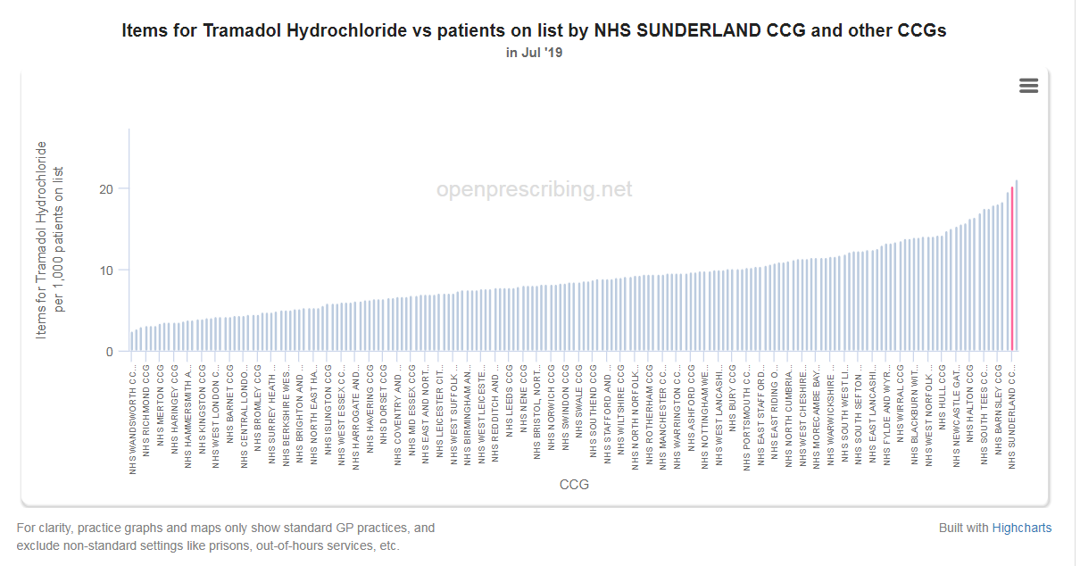
Prescriptions for tramadol = 5,766 in July 2019 alone
Codeine
In July 2019 (latest data available as of Oct ‘19) Sunderland (highlighted in red) was the second highest prescriber for codeine phosphate.

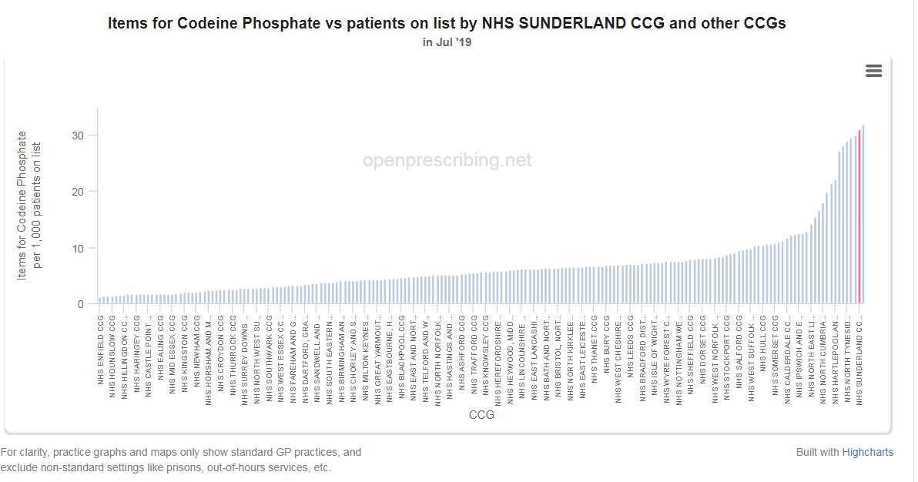
Prescriptions for codeine = 8,832 in July 2019 alone

